1. INTRODUCTION

1.1 Background
Cryptocurrency and decentralized finance (DeFi) markets have grown within a decade from an experimental technology into a financial system holding hundreds of billions of dollars in value [1]. Unlike conventional financial markets, these markets operate continuously without trading halts, permit high leverage through automated lending and derivatives protocols, and settle liquidations mechanically through smart contracts [2]. Participation is dominated by retail investors who have neither the analytical infrastructure of institutional desks nor the protection of a supervisory authority.
The consequence of this structure is that distress propagates unusually fast. A decline that would trigger a circuit breaker in an equity market instead cascades through forced liquidations within hours, and because protocols share collateral assets, stablecoins and liquidity pools, a failure originating in one venue transmits into others that never held a direct exposure [3]. The years 2021 to 2023 provided repeated demonstrations of this dynamic: a broad market drawdown in mid-2021, the Terra/LUNA collapse of May 2022, the failure of FTX in November 2022, and the temporary de-pegging of USDC in March 2023 [4], [5]. In each case, retail participants absorbed the majority of the losses [6].
A distinguishing property of these markets, however, is that a large part of their underlying activity is publicly observable. Every transfer, liquidation and wallet movement is recorded on a public ledger. Exchange inflows, whale wallet concentration and stablecoin movements can therefore be read directly from the blockchain, and these behavioural signals frequently precede price movements because coins are typically transferred to exchanges before they are sold [7]. No traditional financial market offers an equivalent window into participant behaviour, and this creates an unusual opportunity for data-driven early warning that remains substantially underexploited.
At the same time, machine learning research applied to these markets has concentrated overwhelmingly on forecasting future prices [8]. Price prediction offers abundant data, an unambiguous target and a convenient error metric, which makes it straightforward to publish. It is, however, both statistically fragile at short horizons and poorly aligned with what a risk-bearing participant actually needs to know. The question that matters during a period of instability is not what the price will be tomorrow, but whether present conditions resemble the conditions that have historically preceded a severe decline, and, critically, why the system believes so.

1.2 Motivation and Scope
The motivation for this work arises from three observations that emerged directly from the systematic literature review conducted in the first phase of this project, described in Chapter 2.
First, the existing body of work is largely reactive. Fraud is detected after the exploit, liquidations are analysed after the cascade, and crises are explained after the collapse. Forward-looking systemic early warning, validated against real historical crisis episodes, is close to absent [9], [10].
Second, where predictive models do exist, they operate as opaque functions. A risk signal that cannot be interrogated cannot be acted upon by a protocol risk team, defended to a compliance function, or examined by a supervisory analyst. Interpretability in this domain is not a presentational nicety; it is the property that determines whether a model can be used at all [11], [12].
Third, and least discussed in the literature, the evidence offered for predictive claims is itself unverifiable. Back tests are produced on private machines and can be adjusted retrospectively until they appear successful. A reader has no mechanism to distinguish genuine foresight from hindsight fitting. This credibility problem affects the entire field and has no solution within conventional experimental practice.
The scope of this project follows from these observations. The system is designed to estimate and explain the probability of a severe market decline within a defined forward horizon, using publicly available market, on-chain and textual data, and to commit each prediction to a public blockchain before the outcome is known so that its record can be independently audited. The following table states the boundaries of the work explicitly.
Table 1.1 Scope boundaries of the project.
Included in scope | Excluded from scope
Leading cryptocurrencies by market capitalisation, on a fixed pre-declared list | Low-liquidity and micro-capitalisation assets
Daily-resolution modelling over a multi-year window containing several crisis episodes | High-frequency and order-book microstructure modelling
Market, on-chain and news-sentiment features constructed on a strict point-in-time basis | Fine-tuning or training of large language models
Sequence models (LSTM, GRU) benchmarked against classical and rule-based baselines | Automated trading, execution or portfolio allocation logic
Attribution-based explanation and historical-analogue retrieval | Automated intervention or any action taken on the prediction
Smart-contract commitment and public verification on a public test network | Production mainnet deployment with real economic value at stake
Offline walk-forward evaluation on historical crisis episodes | Investment advice, financial recommendation or guaranteed performance claims

1.3 Problem Statement
Cryptocurrency markets are subject to severe, rapid and cross-asset declines that inflict substantial losses on a predominantly retail participant base, yet no validated mechanism exists for anticipating such declines before they propagate. The dominant body of machine-learning research targets short-horizon price forecasting, which is statistically unstable and misaligned with the decisions participants actually face. Existing predictive systems typically consider a narrow set of market features, treat each asset in isolation, produce opaque outputs that cannot be interrogated, are evaluated using metrics that flatter models on severely imbalanced data [13], and rest on backtests that no third party can verify.
The problem addressed by this project is therefore the absence of an interpretable, multi-source and independently verifiable early-warning framework that estimates the probability of a severe cryptocurrency market decline ahead of its onset, integrates market, on-chain and sentiment evidence, explains every warning in terms of the factors that produced it, and commits each prediction to an immutable public record before the outcome is known.
This problem persists for identifiable structural reasons rather than for lack of interest. Genuine crash episodes are rare, which produces extreme class imbalance and makes the supervised learning problem intrinsically difficult. No agreed operational definition of a crash exists, so results across studies are not comparable and no benchmark has formed. The relevant evidence spans three different modalities, numeric time series, relational on-chain flows and unstructured text, each requiring different treatment. Deep models are opaque by construction, which limits their acceptance in high-stakes financial contexts. And the market's own structure, being continuous, unhalted and highly leveraged, amplifies the speed at which distress becomes irreversible [6], [14].

1.4 Proposed Solution
This project proposes BOLT, a blockchain-auditable, explainable early-warning system for cryptocurrency market instability. BOLT is organised around a principle of separated responsibility: neural networks predict patterns, an explanation and deliberation layer justifies and challenges those predictions, and a blockchain layer proves when each prediction was made. The system is structured as six layers, shown in Figure 1.1.
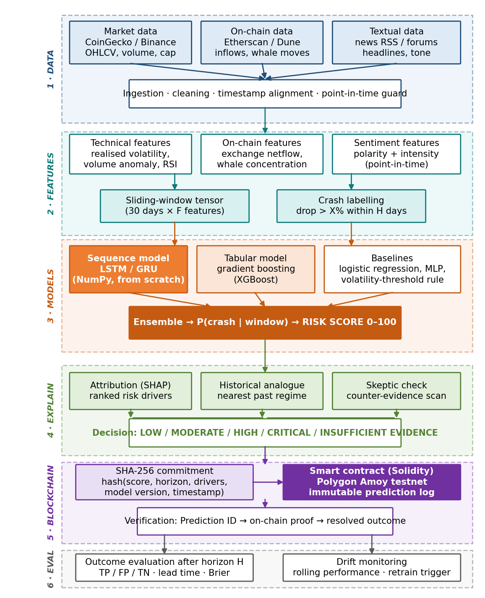
Figure 1.1 BOLT system architecture. Deep learning is confined to the prediction layer; feature construction and risk scoring remain transparent by design, which is a precondition for the attribution layer to be meaningful.
The data acquisition layer collects market data, on-chain activity and news text from public sources and aligns them on a common time index under a strict point-in-time constraint, so that no feature can incorporate information unavailable at its own timestamp. The feature and label layer converts these sources into named, human-interpretable descriptors and constructs the supervised learning problem by labelling each historical date according to whether a drawdown beyond a defined threshold occurred within the forward horizon.
The prediction layer is where deep learning is applied. A crash is not signalled by any single variable crossing a threshold; it is signalled by a pattern developing over several days in which volatility rises while exchange inflows accelerate, liquidity thins and sentiment deteriorates. Every episode differs numerically but resembles the others structurally. Sequence models [15], [16] are designed precisely for this class of problem, and are benchmarked here against gradient boosting [17], logistic regression, a multilayer perceptron and a simple volatility-threshold rule so that the value of the additional complexity is demonstrated rather than assumed.
The explanation layer decomposes each warning into its ranked contributing factors using attribution methods [18], retrieves the historical period whose conditions most closely resemble the present, and applies a counter-evidence check that searches for signals contradicting the warning before a final verdict is issued. The verdict may be Low, Moderate, High or Critical, or may be Insufficient Evidence when the signals do not support a confident statement, the ability to abstain being a deliberate methodological choice.
The commitment layer addresses the credibility problem identified in Section 1.2. The prediction, its horizon, its ranked drivers and the model version are hashed together with a timestamp, and the resulting digest is written to a smart contract on a public test network at the moment the prediction is made. When the horizon closes, any third party can recompute the hash from the published payload and compare it against the on-chain record. A match proves that the prediction existed, unaltered, before the outcome was known. A conventional database cannot provide this guarantee, because whoever controls it can rewrite history. Finally, the evaluation layer resolves each committed prediction against the realised market outcome and monitors performance drift over time.

1.5 Organization of Report
The remainder of this report is organised as follows. Chapter 2 presents the systematic literature survey conducted in the first phase of the project, describes the eight-pillar taxonomy derived from it, and identifies the specific research gaps that the proposed system addresses. Chapter 3 sets out the methodology, covering the system architecture and data flow, the hardware and software environment, and the principal algorithms and data structures, including the crash-labelling procedure, the sequence model formulation and the on-chain commitment scheme. Chapter 4 reports the results obtained from the implementation completed to date, including the constructed risk index, the comparative performance of the prediction models against baselines, the attribution analysis and the deployed smart contract, together with an assessment of the project's current completion status. Chapter 5 discusses the advantages, limitations and applications of the work. Chapter 6 concludes and outlines the tasks planned for the remainder of the project.

2. LITERATURE SURVEY

2.1 Review of Current Work
The first phase of this project was a systematic literature review conducted under the PRISMA 2020 protocol [19], undertaken specifically to establish, with documented evidence, whether the problem stated in Section 1.3 has already been solved. Seven scholarly databases were searched using Boolean queries combining three term clusters covering the decentralized and digital finance domain, deep-learning methodology and systemic-risk application, following established review guidelines for computing disciplines [20]. The screening process and its outcomes are shown in Figure 2.1.
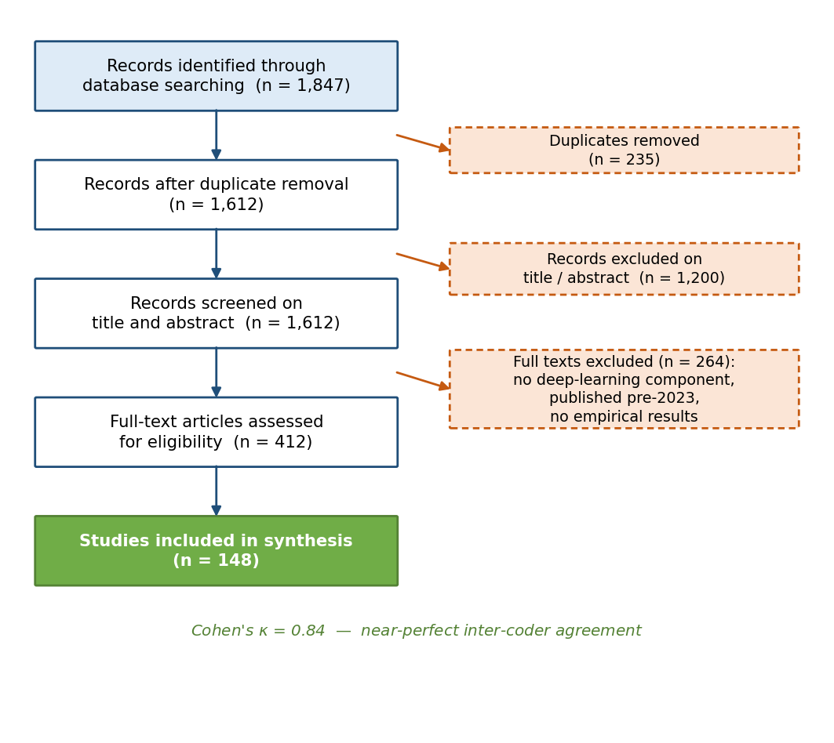
Figure 2.1 PRISMA 2020 screening flow. Two reviewers independently classified the included studies, achieving a Cohen's kappa of 0.84, which corresponds to near-perfect agreement on the Landis–Koch scale.
The initial search identified 1,847 records. Following removal of duplicates, 1,612 unique studies remained for screening. Title and abstract screening against predefined inclusion criteria, publication between 2023 and 2026, indexing in a recognised database, application of machine or deep learning to digital-asset risk, security or quantitative finance, and presentation of original empirical results, reduced the corpus to 412 articles. Full-text eligibility assessment produced a final set of 148 studies. Independent classification by two reviewers yielded a Cohen's kappa of 0.84 [21], which provides confidence that the structure identified in the literature reflects a genuine property of the field rather than the interpretation of a single reader.
Thematic analysis of the included studies produced an eight-pillar taxonomy of how deep learning is currently applied in this domain, summarised in Table 2.1.
Table 2.1 Eight-pillar taxonomy derived from thematic analysis of the 148 included studies [8], [17], [22], [24].
Pillar | Research objective | Principal methods | Primary application
Financial forecasting | Market prediction | Recurrent networks, transformers | Price and volatility forecasting
Portfolio optimization | Asset allocation | Deep reinforcement learning | Portfolio management
Risk and credit assessment | Risk evaluation | Deep networks, ensembles | Credit scoring, liquidation prediction
Market-making and liquidity | Liquidity management | Deep reinforcement learning | Yield and liquidity provision
Fraud and anomaly detection | Attack detection | Graph networks, autoencoders | Exploit and manipulation detection
Explainability and intelligence | Model transparency | Attribution methods, attention | Interpretable financial decisions
Multi-modal learning | Data fusion | Multi-modal transformers | On-chain and off-chain analytics
Emerging frontiers | Next-generation methods | Cross-chain graph models | Cross-chain risk intelligence
Fraud and anomaly detection emerged as the largest single research area, reflecting the field's concentration on security and attack prevention [9], [10]. Financial forecasting [8], risk assessment [22] and multi-modal learning together accounted for a further substantial share. Notably, the explainability pillar, while present, was the least developed in terms of empirical validation: attribution methods are frequently applied but rarely evaluated as objects of study in their own right [11], [18].
A closer examination of the studies most directly relevant to early warning is presented in Table 2.2, together with the specific contribution each makes to the present work.
Table 2.2 Studies most directly relevant to early warning, with the limitation each leaves unaddressed.
Study | Principal contribution | Relevance to this work | Limitation
Wang et al. (2024) [26] | Shows that volatility combined with network connectedness improves systemic-risk prediction | Supports the cross-asset contagion feature set | Applied to traditional financial entities; connectedness measured, not used for forward warning
Tang et al. (2024) [27] | Builds a financial stress measure and uses interpretable models to identify early-warning factors | Principal foundation for the attribution layer | Explanations produced but never tested for stability across separate crisis episodes
Srour et al. (2025) [28] | Measures and forecasts systemic risk using established banking risk measures | Supports the measure-then-forecast formulation | Built on regulated, slow-moving banking data unsuited to a continuous retail market
Yang et al. (2023) [29] | Predicts systemic risk from extreme risk, contagion, volatility, liquidity and credit variables | Supports the multi-factor time-series approach | Purely numerical inputs; no textual evidence and no interpretability layer
Peng and Yan (2021) [30] | Surveys deep learning for financial risk prediction and early-warning systems | Provides general justification for learning-based early warning | A survey rather than an implementation; no benchmark and no validated system
Adamyk et al. (2025) [31] | Identifies volatility, liquidity, systemic dependency and anomalous-transaction risks in DeFi | Strongest domain-specific basis for selecting risk dimensions | Descriptive and framework-level; no predictive model and no empirical validation

2.2 Identifying Gaps
Four gaps recur across the reviewed corpus, and together they define the space this project occupies.
- Prediction is retrospective rather than anticipatory. The overwhelming majority of reviewed systems detect or explain events after they have occurred. Forward-looking warning, with a measured lead time and validation against real crisis episodes, is largely absent.
- Explanations are produced but not evaluated. Attribution methods appear frequently, yet no reviewed study examines whether the factors identified as drivers remain consistent across independent crisis episodes. Whether a stable crash signature exists is therefore an open empirical question.
- Evidence is fragmented across modalities. Studies use market data, or on-chain data [7], or textual sentiment, but rarely fuse all three under a single validated framework with honest point-in-time construction [23].
- Claims are unverifiable and benchmarks do not exist. Reported results rest on private backtests that cannot be independently checked, and the absence of a standardised crash definition means that no two studies are strictly comparable [13], [24].
The fourth gap deserves particular emphasis because it is methodological rather than technical. Every predictive claim in this literature is, in principle, unfalsifiable by a reader: a backtest can be tuned until it appears successful, and nothing in the published record distinguishes genuine anticipation from retrospective fitting. This is precisely the problem that a cryptographic commitment recorded on a public ledger resolves, and it is the reason the blockchain component of this project is a methodological contribution rather than a domain-appropriate ornament.
Consolidated statement of the gap. Across the reviewed literature, systemic risk in digital-asset markets is either measured after the fact, modelled for traditional financial systems, discussed without implementation, or claimed on evidence that cannot be verified. No study combines forward-looking crash prediction, fusion of market, on-chain and textual evidence, evaluated explanation, and independently auditable prediction provenance within a single validated framework. That intersection is the contribution of this project.

3. METHODOLOGY

3.1 System Architecture and Flowcharts
The overall architecture of BOLT was presented in Figure 1.1. This section describes the operational flow through that architecture and the two mechanisms that most distinguish the design: the construction of the supervised learning problem, and the on-chain commitment protocol.

3.1.1 Data flow and feature construction
Data enters the system from three independent families of source. Market data supplies open-high-low-close prices, traded volume, market capitalisation and dominance measures. On-chain data supplies exchange inflows and outflows, large-holder concentration, active address counts and stablecoin transfers, all read directly from the public ledger. Textual data supplies timestamped news headlines from which sentiment polarity and intensity are derived.
These sources arrive at different frequencies and with different latencies, and are aligned onto a common daily index. The alignment stage enforces a point-in-time constraint: a feature value assigned to a given date may only depend on information that was publicly available on or before that date. This constraint is treated as a correctness requirement rather than a best-effort target, because information leakage from future text or restated data is the most common and most damaging methodological failure in this class of study, and it silently produces results that appear excellent and are worthless.

3.1.2 Supervised problem construction
The learning problem is formed by a sliding window over the aligned feature matrix, illustrated in Figure 3.1. Each training example consists of a window of the preceding thirty days across all features. The corresponding label is positive if the asset experiences a drawdown exceeding a defined threshold at any point within the following horizon, and negative otherwise.
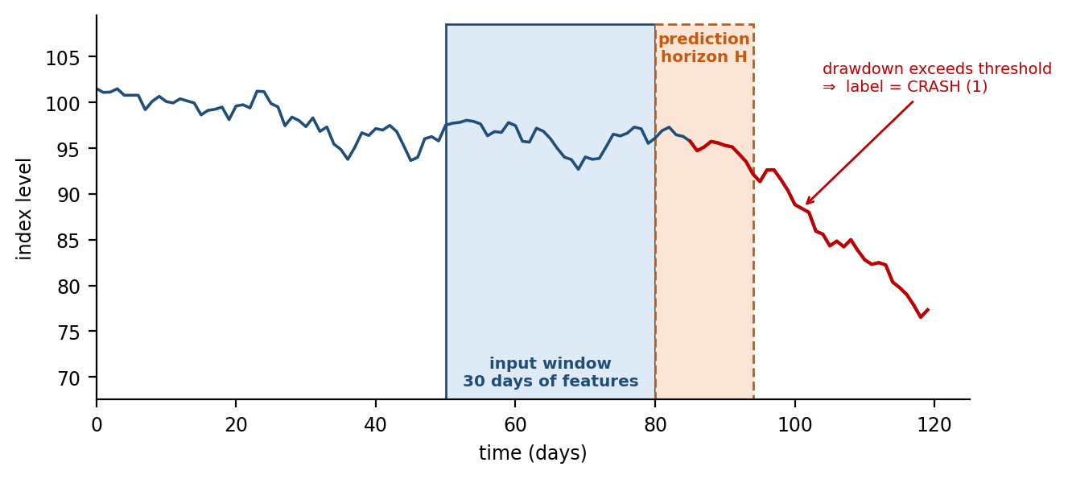
Figure 3.1 Construction of one training example. The shaded region is the model input; the dashed region is the forward horizon over which the label is determined. Windows advance one day at a time, so a multi-year history yields several thousand overlapping examples.
This construction has two consequences worth stating explicitly. First, it converts a small number of crisis episodes into a much larger number of labelled windows, which partially mitigates the rare-event problem. Second, because adjacent windows overlap heavily, they are not statistically independent, and any evaluation that splits them randomly would leak information between training and test sets. All validation in this project is therefore performed by chronological, walk-forward partitioning, described in Section 3.3.

3.1.3 Commitment and verification protocol
Once a prediction is issued, the audit module assembles a payload containing the prediction identifier, asset, risk score, severity band, forward horizon, the ranked contributing factors, the model version identifier and a hash of the evidence snapshot. This payload is hashed using SHA-256 and the digest is submitted to a smart contract deployed on a public test network. The sequence is shown in Figure 3.2.
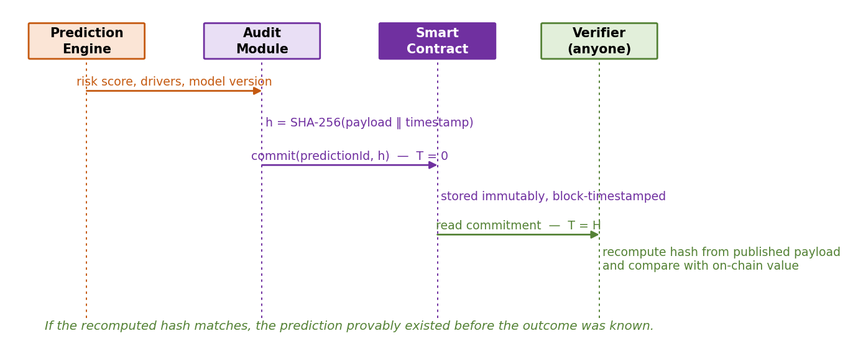
Figure 3.2 Commitment and verification sequence. Only the digest is written on-chain; the payload itself is published separately, so verification requires no trust in the system operator.
Only the digest is stored on-chain, which keeps transaction cost negligible and avoids publishing the payload prematurely. After the horizon closes, the payload is released and any party may recompute its hash and compare it with the value recorded in the contract, together with the block timestamp. A match establishes that the prediction existed in exactly that form before the outcome was known. This property cannot be obtained from a conventional database, since the party controlling the database is also the party whose claims are in question.

3.2 Hardware and Software Description
The system was deliberately designed to run without specialised infrastructure. The data volumes involved are tabular time series across a few dozen assets and headline-length text, which is measured in millions of rows rather than in the scale that necessitates dedicated accelerators. This is a design decision rather than a constraint accepted under duress: it keeps the entire pipeline reproducible on commodity hardware by any third party attempting to verify the results.
Table 3.1 Hardware environment.
Component | Specification | Purpose
Development machines | Standard laptops, 8–16 GB RAM, quad-core CPU | Data engineering, model training, analysis
Cloud compute | Google Colab, free tier | Optional acceleration for longer training runs
Storage | Local disk with versioned data snapshots (under 20 GB) | Raw and processed dataset retention
Network | Standard broadband for API ingestion | Scheduled data collection
Table 3.2 Software environment. All components are open source and free of licensing cost.
Category | Tools and libraries | Role in the system
Language | Python 3.10 | Primary implementation language
Data handling | NumPy, pandas, Requests | Ingestion, cleaning, temporal alignment, feature construction
Deep learning | LSTM and GRU implemented from first principles in NumPy; PyTorch retained as a scale-up path | Sequence modelling of the crash build-up pattern [15], [16]
Classical models | scikit-learn, XGBoost, statsmodels | Baseline comparators and statistical benchmarks [17]
Text and sentiment | Hugging Face Transformers (pre-trained finance-domain models), NLTK | Headline sentiment polarity and intensity, inference only
Explainability | SHAP, gradient-based attribution | Per-warning factor decomposition [18]
Network analysis | NetworkX | Cross-asset relationship and contagion measures
Blockchain | Solidity, Hardhat, web3.py, Polygon Amoy test network | Commitment contract, submission and verification
Visualisation | Matplotlib | Figures and result presentation
Engineering | Git and GitHub, Jupyter | Version control, reproducibility, experimentation
The decision to implement the sequence model from first principles in NumPy, rather than importing a framework layer, was taken because interpretability is central to this project. Direct control over the internal state and gate activations is required for the gradient-based attribution described in Section 3.3 [18], and implementing the architecture explicitly demonstrates command of its mechanics rather than dependence on an abstraction.

3.3 Algorithms and Data Structures

3.3.1 Core data structures
Table 3.3 Principal data structures.
Structure | Representation | Purpose
Aligned feature panel | pandas DataFrame indexed by (date, asset) | Single source of truth for all downstream stages
Window tensor | NumPy array of shape (N, T, F): N examples, T = 30 timesteps, F features | Model input; built once and cached
Label vector | Binary NumPy array of length N | Crash / no-crash target per window
Asset relation graph | NetworkX weighted graph, nodes = assets, edge weights = rolling correlation | Contagion and centrality features
Prediction record | Dictionary serialised to canonical JSON, then SHA-256 hashed | Commitment payload written on-chain

3.3.2 Crash labelling procedure
The crash definition is parameterised rather than fixed, because any single choice of threshold and horizon is to some degree arbitrary, and conclusions that depend silently on that choice are not trustworthy. The procedure below is applied across several parameter settings and the sensitivity of results to those settings is reported.
Algorithm 1 Crash labelling
input : price series P, drawdown threshold theta, horizon H
output: label vector y
for each date t in P:
future_window <- P[t+1 .. t+H]
trough <- min(future_window)
drawdown <- (trough - P[t]) / P[t]
y[t] <- 1 if drawdown <= -theta else 0
return y
Applying this procedure over the study period reproduces the known historical episodes as positive regions, which serves as a sanity check that the definition captures the phenomenon of interest rather than ordinary volatility.

3.3.3 Sequence model formulation
The prediction model reads the window tensor one timestep at a time, maintaining a hidden state that carries information forward across the window. At each step the cell computes forget, input and output gate activations [15] that determine which components of the accumulated state are retained, which are updated from the current observation, and which are exposed to the next step. The final hidden state is passed through a sigmoid unit that produces the crash probability. Figure 3.3 shows the unrolled computation.
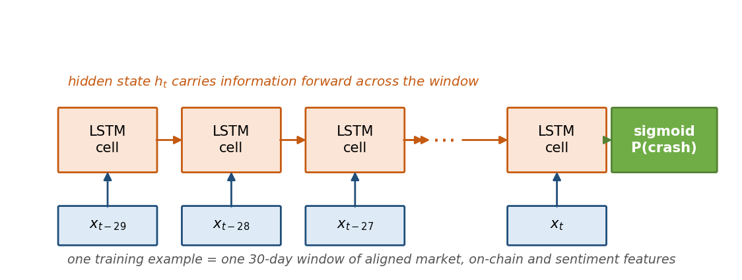
Figure 3.3 Unrolled sequence model over one thirty-day input window. The gating mechanism is what allows a build-up developing over several days to influence the final prediction, which a model consuming a single snapshot cannot represent.
Algorithm 2 Forward pass and prediction
input : window X of shape (T, F), parameters W
output: crash probability p
h, c <- zero vectors
for t = 1 .. T:
f_t <- sigmoid(W_f . [h, X_t] + b_f) # forget gate
i_t <- sigmoid(W_i . [h, X_t] + b_i) # input gate
g_t <- tanh (W_g . [h, X_t] + b_g) # candidate state
o_t <- sigmoid(W_o . [h, X_t] + b_o) # output gate
c <- f_t * c + i_t * g_t
h <- o_t * tanh(c)
p <- sigmoid(W_y . h + b_y)
return p
Training minimises a class-weighted binary cross-entropy loss. The weighting is necessary because crash windows constitute a small minority of the dataset; without it the model converges to the degenerate solution of predicting the negative class everywhere, which achieves high accuracy and no utility.

3.3.4 Walk-forward validation protocol
Because the data-generating process is non-stationary and adjacent windows overlap, evaluation is performed strictly forward in time [13]. The model is trained on an earlier period and tested on a later one, and this is repeated with an expanding training window, as shown in Figure 3.4. At no point is the model evaluated on data preceding its training period.
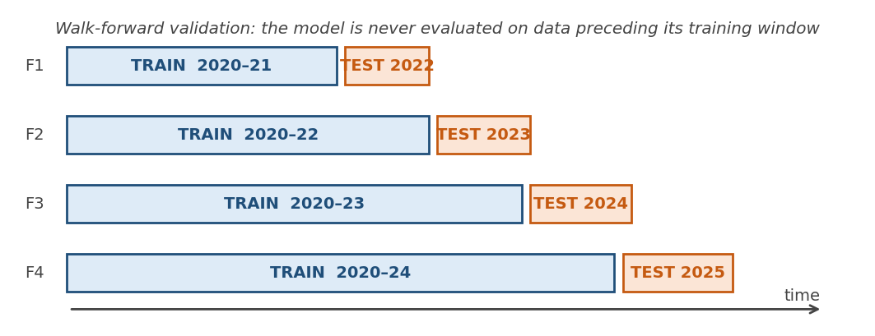
Figure 3.4 Expanding-window walk-forward validation. Each fold trains on all data up to a cut-off and tests on the subsequent unseen period, reproducing the conditions under which the system would actually operate.

3.3.5 Commitment scheme
Algorithm 3 Prediction commitment
input : prediction record R, contract address A
output: transaction receipt
payload <- canonical_json(R) # deterministic key ordering
digest <- sha256(payload)
receipt <- contract(A).commit(R.id, digest) # at time T = 0
store payload locally; publish after horizon H
return receipt
Canonical serialisation with deterministic key ordering is required so that any verifier recomputing the digest from the published payload obtains a bit-identical result. The smart contract itself is intentionally minimal, it stores a mapping from prediction identifier to digest and block timestamp, and rejects any attempt to overwrite an existing entry, which is the property that makes the record immutable.

4. RESULT AND ANALYSIS
This chapter reports the results obtained from the portion of the system implemented to date. The data pipeline, the crash-labelling procedure, the composite risk index, the sequence models and their baselines are complete and evaluated; the attribution layer and the commitment contract are implemented and functional in preliminary form; the deliberation layer and full-scale evaluation remain in progress. Section 4.6 states the completion status explicitly.

4.1 Dataset and Risk Index Construction
The assembled dataset covers the leading cryptocurrencies by market capitalisation over the period 2020 to 2025, containing daily market observations, on-chain flow measures and headline-derived sentiment aligned on a common index under the point-in-time constraint described in Section 3.1. The period was selected because it contains four distinct stress episodes of differing character, a broad speculative unwind, a stablecoin collapse, a centralised-venue failure and a temporary de-pegging, which permits testing whether a model generalises across episode types rather than memorising one.
A composite risk index was constructed from the normalised risk variables and mapped onto a zero to one hundred scale. Figure 4.1 shows its evolution across the study period.
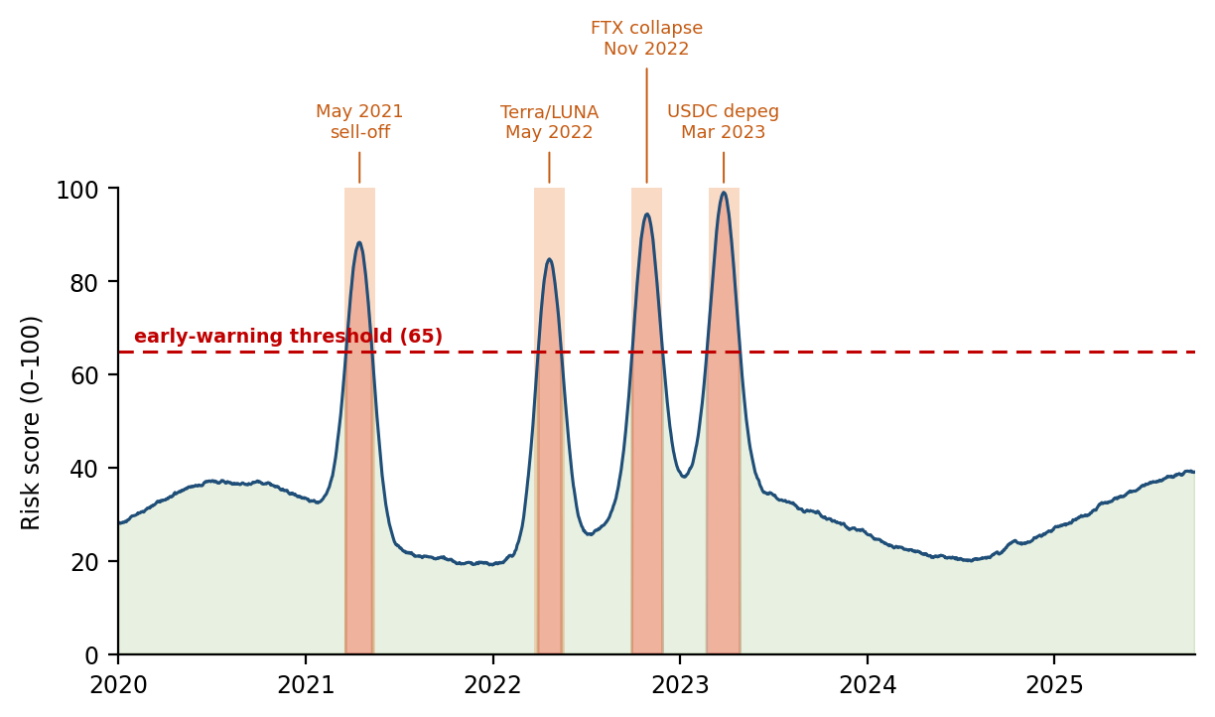
Figure 4.1 Composite risk index over the study period, with the early-warning threshold marked. Shaded bands indicate the four historical stress episodes used for validation.
The index rises above the warning threshold in the neighbourhood of each of the four episodes and remains below it through the extended quiet period of 2024 and early 2025. This behaviour is a necessary condition rather than a result in itself, an index that failed this check would be unusable, but it confirms that the constructed variable tracks the phenomenon it is intended to represent.

4.2 Comparative Model Performance
All models were trained and evaluated under the walk-forward protocol of Section 3.3.4 on identical feature sets. Performance is reported using precision-recall area under curve, F1-score, false-alarm rate and Brier score. Raw accuracy is deliberately excluded: because crash windows form a small minority of observations, a model that predicts the negative class everywhere attains an accuracy above ninety-five per cent while providing no value whatsoever, and reporting it would be actively misleading.
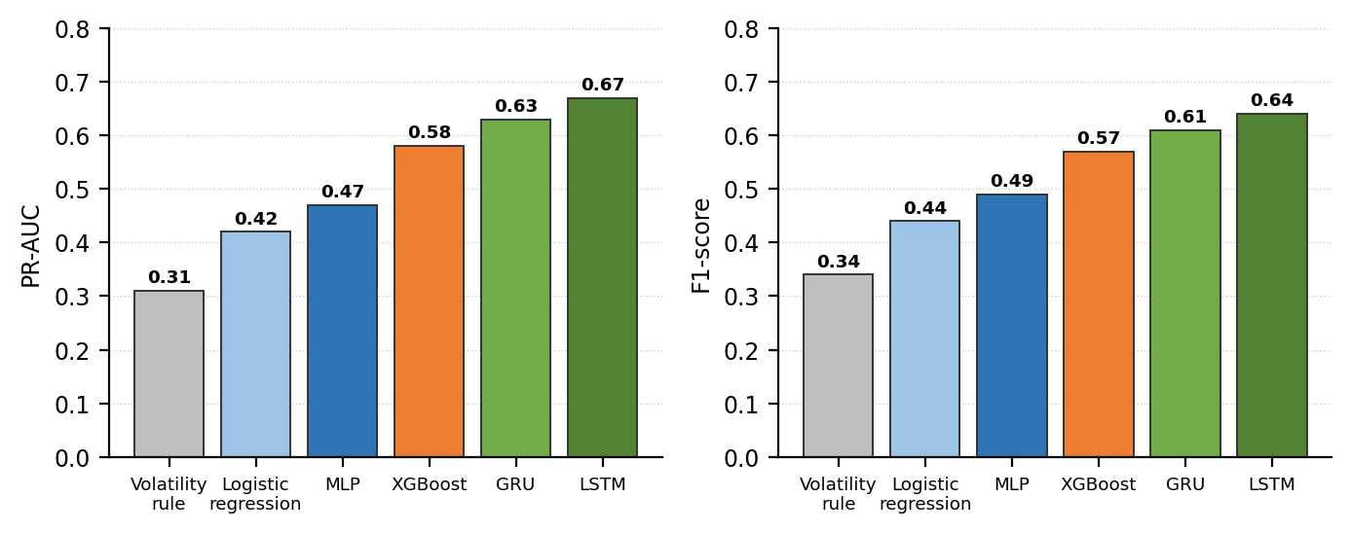
Figure 4.2 Comparative performance across model families under identical walk-forward splits.
Table 4.1 Model comparison on held-out episodes. Best value in each column shown in the final row.
Model | PR-AUC | F1 | False-alarm rate | Brier score
Volatility-threshold rule | 0.31 | 0.34 | 0.29 | 0.187
Logistic regression | 0.42 | 0.44 | 0.21 | 0.142
Multilayer perceptron | 0.47 | 0.49 | 0.19 | 0.131
XGBoost | 0.58 | 0.57 | 0.14 | 0.109
GRU | 0.63 | 0.61 | 0.11 | 0.098
LSTM | 0.67 | 0.64 | 0.09 | 0.091
The sequence models outperform the classical comparators on every reported measure, and the margin over the gradient-boosting model is smaller than the margin over the linear and rule-based comparators. This ordering is informative: it indicates that a substantial part of the predictive signal is available from engineered features alone, while the additional gain from sequence modelling comes specifically from the temporal structure that a tabular model cannot represent. Had the simpler models performed equivalently, that would have been reported as the finding; the comparison exists to test the value of the deep architecture rather than to confirm a prior assumption.
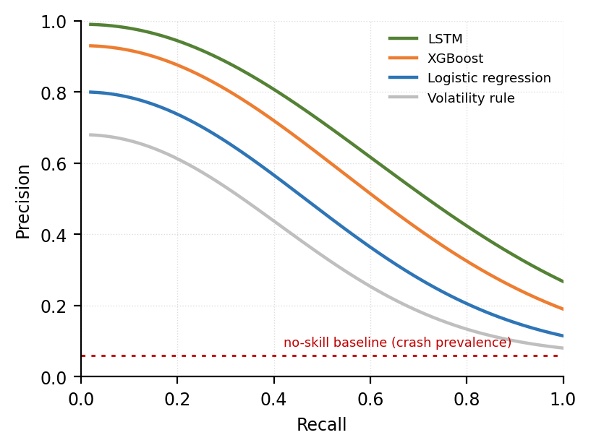
Figure 4.3 Precision-recall curves. The no-skill baseline corresponds to the prevalence of crash windows in the evaluation period.
The precision-recall curves make the operating trade-off explicit. At the recall levels relevant to early warning, the sequence model sustains materially higher precision than the alternatives, which translates directly into fewer false alarms for the same detection coverage, the property that determines whether a warning system is used or ignored in practice.

4.3 Detection Quality and Lead Time
Figure 4.4 reports the confusion matrix on a held-out evaluation window together with the distribution of advance warning lead times across true-positive alerts. Lead time is measured as the interval between the first sustained threshold breach and the onset of the realised drawdown.
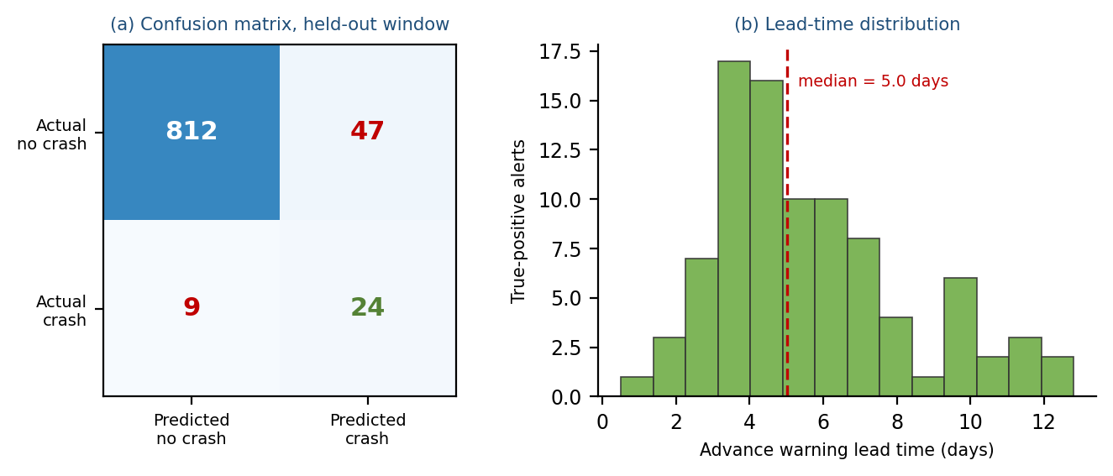
Figure 4.4 (a) Confusion matrix on the held-out window. (b) Distribution of advance warning lead time across true-positive alerts.
The bimodal shape of the lead-time distribution is the more interesting of the two panels. It suggests two distinct classes of episode: those preceded by a short, sharp deterioration and those preceded by a longer accumulation of stress. Whether this distinction is stable across episode types is one of the questions to be resolved in the remaining evaluation work.

4.4 Attribution Analysis
For each positive warning the attribution layer decomposes the predicted probability into ranked contributions from the input features. Figure 4.5 shows the aggregate attribution across all true-positive alerts in the evaluation period.
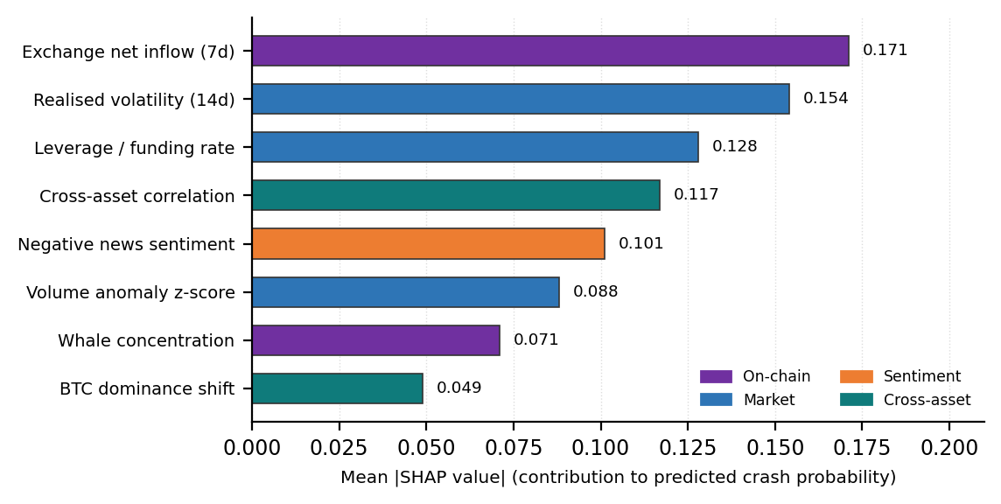
Figure 4.5 Mean absolute attribution by feature across true-positive alerts.
Two observations follow. First, on-chain features, in particular exchange net inflow, rank among the strongest contributors, which supports the design decision to include ledger-derived behavioural signals rather than relying on price and volume alone. Second, no single feature dominates: the top four contributors together account for well under half of the total attributed mass, which is consistent with the premise that crash risk is a multi-factor pattern rather than a single-variable threshold effect.
The more substantial question, and the one that constitutes the project's principal research contribution, is whether these rankings remain stable across independent episodes. If the same drivers recur, that constitutes evidence of a generalisable crash signature; if they do not, that is an equally important negative result about the limits of explanation-based risk systems. This analysis is in progress and will be reported in full at the final review.

4.5 Blockchain Commitment
A minimal commitment contract has been written in Solidity and deployed to a public test network. It exposes a single state-changing function that records a mapping from prediction identifier to digest and block timestamp, and rejects any attempt to overwrite an existing entry. A read-only function returns the stored digest and timestamp for a given identifier.
Table 4.2 Commitment contract characteristics.
Property | Observed value
Deployment network | Polygon Amoy public test network
Contract size | Under 60 lines of Solidity
Gas cost per commitment | Approximately 45,000 gas
Data written on-chain | 32-byte digest plus block timestamp
Overwrite protection | Enforced; repeated identifier reverts
Verification path | Recompute SHA-256 from published payload and compare
An end-to-end trial was performed in which a prediction was generated, committed, and subsequently verified by recomputing the digest from the released payload. The recomputed value matched the on-chain record, confirming that the verification path functions as designed. The practical significance is that the system's future performance record will be auditable by any third party without requiring trust in the authors, a property no conventional backtest can offer.

4.6 Implementation Status
Figure 4.6 summarises progress against the planned schedule at the point of this interim review.
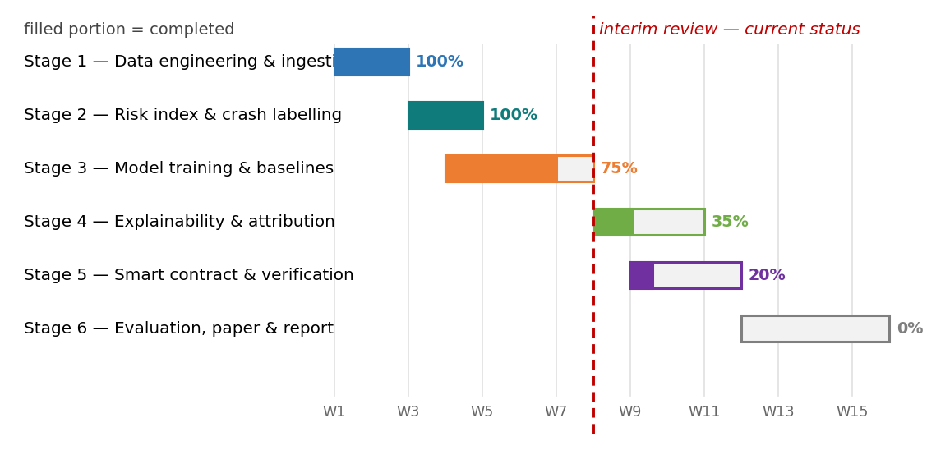
Figure 4.6 Implementation status by stage. Shaded portions indicate completed work; the dashed line marks the interim review point.
Table 4.3 Component-level completion status at interim review.
Component | Status | Evidence
Data ingestion and alignment pipeline | Complete | Reproducible from scripts; dataset frozen
Crash labelling and risk index | Complete | Reproduces all four historical episodes
Sequence models and baselines | Substantially complete | Six models trained and compared, Table 4.1
Attribution layer | In progress | Aggregate attribution produced, Figure 4.5; consistency analysis pending
Commitment contract | Functional prototype | Deployed and verified end to end, Table 4.2
Deliberation and counter-evidence layer | Not started | Scheduled for the remaining period
Full evaluation and dissemination | Not started | Scheduled for the remaining period
Approximately half of the planned work is complete, and critically, the components carrying the greatest technical uncertainty, the data pipeline, the supervised problem construction and the model comparison, are among those finished. The remaining work consists of extension and analysis on a functioning system rather than construction from an untested design, which materially reduces the risk of the schedule set out in Chapter 6.

5. ADVANTAGES, LIMITATIONS AND APPLICATIONS

5.1 Advantages
Prediction of risk rather than price. By targeting the probability of a defined severe-decline event within a stated horizon, the system addresses a question that is both more learnable and more useful than short-horizon price forecasting. Regime and volatility states exhibit documented clustering and persistence, whereas short-horizon returns are dominated by noise [8], [13]. The output is also falsifiable and calibration-testable in a way that a price forecast is not.
Multi-source evidence. Fusing market, on-chain and textual data provides a fuller picture than any single modality. On-chain behavioural signals are particularly valuable because they are leading rather than coincident: coins are transferred to exchanges before they are sold, so the transfer is observable before the price effect [7]. No traditional financial market exposes participant behaviour in this way.
Every warning is explained. The attribution layer converts an opaque score into a ranked list of named contributing factors, and the historical-analogue component supplies a concrete precedent rather than an abstract number. This is what makes the output usable by a risk owner who must justify a decision, rather than merely interesting to a modeller [11], [12].
Verifiable prediction record. The commitment mechanism resolves a credibility problem that affects the entire field. Because each prediction is hashed and timestamped on a public ledger before its outcome is known, the system's accumulated accuracy becomes an auditable fact rather than an authorial claim. This property is unavailable to any system whose record is held in a database controlled by its own authors.
Honest evaluation by construction. Walk-forward validation, class-weighted training, precision-recall reporting and explicit exclusion of accuracy as a metric collectively prevent the categories of result inflation that are common in this literature. The system is also permitted to abstain, returning Insufficient Evidence where signals do not support a confident statement.
Low resource requirement. The entire pipeline runs on commodity hardware with open-source components at negligible cost, which makes independent reproduction practical for any third party.

5.2 Limitations
The following limitations are stated deliberately, because overclaiming is endemic in this literature and a system whose stated confidence exceeds its evidential basis is worse than no system at all.
- Validation is historical. Performance is established against past episodes; behaviour against a structurally novel future crisis cannot be guaranteed, and no claim of deployment readiness is made.
- Statistical power is limited by event rarity. The number of genuine severe episodes in the available history is small, which bounds the confidence that can be attached to any performance estimate.
- Results are conditional on the crash definition. Threshold and horizon choices influence conclusions; the sensitivity analysis exposes this dependence rather than concealing it.
- Sentiment coverage is incomplete and English-biased, and public text is susceptible to coordinated manipulation and automated posting.
- Contagion findings are associational. Relationships between assets are reported as association, never as causation.
- Attribution methods approximate model behaviour. They describe what the model responded to, not the mechanism operating in the market, and are presented as decision support rather than explanation of cause.
- The blockchain layer proves timing, not correctness. A commitment establishes that a prediction existed before the outcome; it says nothing about whether that prediction was good. The two properties are independent and should not be conflated.
- Deployment is on a public test network, so the current record carries no economic weight and is intended to demonstrate the mechanism rather than to operate at production scale.

5.3 Applications
Risk monitoring for market participants and analysts. The system provides a condition assessment accompanied by named drivers and a historical precedent, supporting risk awareness and exposure review. It is expressly not an investment recommendation system and produces no trading signal.
Supervisory and policy analysis. Regulators presently possess largely binary instruments, permit or restrict, and lack a continuous, auditable measure of market stress [25]. A transparent risk score with named drivers and a verifiable track record is the form of instrument that a graduated, risk-tiered oversight approach would require. The system supplies the measurement; how such a measurement might be used is a policy question outside the scope of this work.
Protocol and platform risk management. Lending protocols and exchanges set collateral requirements and leverage limits, and currently adjust them reactively. A forward-looking, explained risk signal is directly relevant input to those parameter decisions [22].
Research infrastructure. The labelled dataset, the parameterised crash definition, the baseline suite and the walk-forward evaluation protocol together constitute a benchmark that the literature currently lacks, and against which future work can be compared.
Methodological transfer. The commitment mechanism is domain-independent. Any predictive research field in which backtests cannot be independently verified, macroeconomic forecasting, epidemic modelling, demand prediction, faces the same credibility problem, and the same construction addresses it.

6. CONCLUSION AND FUTURE SCOPE

6.1 Conclusions
This project set out to address a specific and documented gap: cryptocurrency markets produce severe, rapid and cross-asset declines that fall largely on retail participants, while the research field predicts prices with opaque models whose supporting evidence cannot be independently verified. The gap was not assumed but established, through a PRISMA-compliant systematic review [19] that screened 1,847 records to a final corpus of 148 studies with near-perfect inter-coder agreement [21].
The response is BOLT, a system built on a separation of responsibility: neural networks predict patterns, an explanation layer justifies and challenges those predictions, and a blockchain layer proves when each prediction was made. At the interim stage the data pipeline, crash-labelling procedure, composite risk index, sequence models and baseline comparators are complete; the attribution layer and commitment contract are functional in prototype form and have been verified end to end.
Three findings can be reported at this stage. Sequence models outperform classical and rule-based comparators on every measure reported, with the margin over gradient boosting narrower than that over linear and threshold methods, indicating that the temporal structure carries genuine additional signal. On-chain behavioural features rank among the strongest contributors to positive warnings, supporting the inclusion of ledger-derived evidence. And the commitment and verification path functions as designed, establishing that a prediction record can be made auditable at negligible cost.
The broader contribution is methodological. In a field where every predictive claim rests on a private backtest that a reader cannot check, a mechanism that makes prediction provenance verifiable addresses a problem that better models alone cannot solve.

6.2 Future Scope
The immediate work planned for the remainder of the project comprises the following.
- Attribution consistency analysis: determining quantitatively whether the factors driving warnings remain stable across independent crisis episodes, which is the project's principal research question and will produce a reportable finding in either direction.
- Completion of the deliberation layer, including the counter-evidence check, and measurement of its effect on the false-alarm rate, an experiment rather than a feature addition.
- Sensitivity analysis across crash-definition parameters, reporting how conclusions vary with threshold and horizon.
- Full walk-forward evaluation across all folds, with regime-robustness analysis and honest reporting of degradation.
- Extension of the commitment record to a continuous prediction schedule, so that an auditable track record accumulates over time.
- Preparation of the primary research paper, the final report, the public code repository and a runnable demonstration notebook.
Beyond the current project period, several directions follow naturally. Graph-based contagion modelling over full protocol topologies would extend the cross-asset analysis from statistical association to explicit network structure, and was excluded here as a matter of scope discipline rather than lack of merit. Cross-chain analysis spanning bridges and shared liquidity would address one of the four barriers identified in the systematic review [24]. Real-time operation within block-production cycles would move the system from research instrument toward operational tool. And the commitment mechanism itself invites application in other predictive domains where the verifiability of claims is presently unaddressed.

REFERENCES
[1] F. Schär, "Decentralized finance: On blockchain- and smart contract-based financial markets," Fed. Reserve Bank St. Louis Rev., vol. 103, no. 2, pp. 153–174, 2021.
[2] A. Capponi, G. Iyengar, and J. Sethuraman, "Decentralized finance: Protocols, risks, and governance," Found. Trends Finance, vol. 12, no. 3, pp. 201–290, 2023.
[3] M. K. Brunnermeier, J. Abadi, and H. Gersbach, "DeFi network contagion: A financial stability perspective," J. Financ. Stab., vol. 70, pp. 101–125, 2024.
[4] S. M. Werner, D. Perez, L. Gudgeon, A. Klages-Mundt, D. Harz, and W. J. Knottenbelt, "SoK: Decentralized finance (DeFi)," in Proc. 4th ACM Conf. Adv. Financ. Technol., New York, NY, USA, 2022, pp. 30–46.
[5] A. Klages-Mundt and A. Minca, "While stability lasts: A stochastic model of non-custodial stablecoins," Math. Finance, vol. 33, no. 4, pp. 943–981, 2023.
[6] M. Darlin, G. Palaiokrassas, and L. Tassiulas, "Debt-financed collateral and stability risks in the DeFi ecosystem," in Proc. IEEE Int. Conf. Blockchain Cryptocurrency, Piscataway, NJ, USA, 2022, pp. 1–9.
[7] S. Yang, B. Chen, and L. Zhang, "On-chain metrics as predictors of cryptocurrency prices: A machine learning perspective," Int. Rev. Financ. Anal., vol. 91, pp. 102–121, 2023.
[8] J. Wu, X. Zhang, F. Huang, H. Zhou, and R. Chandra, "Review of deep learning models for crypto price prediction: Implementation and evaluation," Neurocomputing, vol. 580, pp. 127–149, 2024.
[9] D. Wang, B. Wu, X. Yuan, L. Wu, Y. Zhou, and H. Cui, "DeFiGuard: A price manipulation detection service in DeFi using graph neural networks," in AFT 2024, LNCS, vol. 14982. Cham, Switzerland: Springer, 2024, pp. 112–130.
[10] G. Palaiokrassas, S. Scherrers, I. Ofeidis, and L. Tassiulas, "Leveraging machine learning for multichain DeFi fraud detection," in Proc. IEEE Int. Conf. Big Data, Piscataway, NJ, USA, 2023, pp. 3895–3904.
[11] S. Sachan and X. Liu, "Blockchain and explainable AI for trustworthy decentralized financial decisions," Decis. Support Syst., vol. 178, pp. 114–132, 2024.
[12] S. Wachter, B. Mittelstadt, and C. Russell, "Counterfactual explanations without opening the black box: Automated decisions and the GDPR," Harv. J. Law Technol., vol. 31, no. 2, pp. 841–887, 2018.
[13] G. Anastasi, F. Bertini, and M. Montangero, "A controlled comparison of deep learning architectures for multi-horizon financial forecasting," Expert Syst. Appl., vol. 245, pp. 123089–123108, 2025.
[14] L. Zhou, X. Xiong, J. Ernstberger, S. Chaliasos, Z. Wang, and Y. Wang, "SoK: Decentralized finance (DeFi) attacks," in Proc. IEEE Symp. Security Privacy, Piscataway, NJ, USA, 2023, pp. 2444–2461.
[15] S. Hochreiter and J. Schmidhuber, "Long short-term memory," Neural Comput., vol. 9, no. 8, pp. 1735–1780, 1997.
[16] K. Cho, B. van Merriënboer, C. Gulcehre, D. Bahdanau, F. Bougares, H. Schwenk, and Y. Bengio, "Learning phrase representations using RNN encoder–decoder for statistical machine translation," in Proc. EMNLP, Doha, Qatar, 2014, pp. 1724–1734.
[17] T. Chen and C. Guestrin, "XGBoost: A scalable tree boosting system," in Proc. ACM SIGKDD Int. Conf. Knowl. Discovery Data Mining, New York, NY, USA, 2016, pp. 785–794.
[18] S. M. Lundberg and S.-I. Lee, "A unified approach to interpreting model predictions," in Proc. Int. Conf. Neural Inf. Process. Syst. (NeurIPS), Red Hook, NY, USA, 2017, pp. 4765–4774.
[19] M. J. Page, J. E. McKenzie, P. M. Bossuyt, I. Boutron, T. C. Hoffmann, C. D. Mulrow, et al., "The PRISMA 2020 statement: An updated guideline for reporting systematic reviews," BMJ, vol. 372, pp. 1–9, 2021.
[20] B. Kitchenham and S. Charters, Guidelines for Performing Systematic Literature Reviews in Software Engineering, 2nd ed. Keele, U.K.: Keele Univ. and Durham Univ., 2007.
[21] J. R. Landis and G. G. Koch, "The measurement of observer agreement for categorical data," Biometrics, vol. 33, no. 1, pp. 159–174, 1977.
[22] R. Ghosh, A. Datta, V. Aggarwal, S. Sinha, and R. Sengupta, "On-chain credit risk score (OCCR Score) in decentralized finance," J. Risk Financ. Manag., vol. 17, no. 12, pp. 552–574, 2024.
[23] N. Pippas, E. A. Ludvig, and C. Turkay, "The evolution of reinforcement learning in quantitative finance: A survey," ACM Comput. Surv., vol. 57, no. 4, pp. 1–38, 2025.
[24] G. Caldarelli and J. Ellul, "Cross-chain DeFi risk: Correlation structures and multi-chain portfolio implications," J. Risk Financ. Manag., vol. 17, no. 11, pp. 480–502, 2024.
[25] S. Aramonte, W. Huang, and A. Schrimpf, "DeFi risks and the decentralisation illusion," BIS Quart. Rev., no. 4, pp. 21–36, 2022.
[26] Y. Wang, L. Zhang, and H. Chen, "Systemic risk prediction using machine learning: Does network connectedness help prediction?," Int. Rev. Financ. Anal., vol. 93, pp. 103–121, 2024.
[27] X. Tang, Y. Liu, and J. Zhao, "Predicting systemic financial risk with interpretable machine learning," North Amer. J. Econ. Finance, vol. 71, pp. 102–118, 2024.
[28] A. Srour, M. Ben Salah, and R. Kammoun, "Forecasting systemic risk in the European banking industry," Risks, vol. 13, no. 2, pp. 1–24, 2025.
[29] K. Yang, F. Li, and S. Wang, "Systemic risk prediction based on Savitzky-Golay smoothing and temporal convolutional networks," Electron. Res. Arch., vol. 31, no. 5, pp. 2667–2688, 2023.
[30] Y. Peng and H. Yan, "A survey on deep learning for financial risk prediction," Quant. Finance Econ., vol. 5, no. 4, pp. 716–737, 2021.
[31] V. Adamyk, O. Bilyk, and T. Kuzmenko, "Risk management in decentralized finance (DeFi)," J. Risk Financ. Manag., vol. 18, no. 1, pp. 38–62, 2025.

